Release Assembly - TopCoder Cockpit Submission Viewer Revamp Deployment Guide

Revision History
Author | Revision Number | Date
TCSASSEMBLER | 1 | 2011-12-04

1. Organization of Submission 3
2. Application Setup 3
3. Ant .Properties File for direct project 3
4. Build scripts Setup 3
5. Deployment Instructions 3
6. Starting 3
7. Verification 4
8. Resource Contact List 6

Organization of Submission
This assembly updates the studio submission viewer of the TopCoder Cockpit.

- project: the folder for updated/new files of direct project
- doc: this folder for deployment guide, it contains this file Deployment_Guide.doc
- sql: the folder for test-data sql script.

Application Setup

The application is expected to be deployed to the following environment:

- JRE 1.5
- JBoss 4.2.3.GA
- Informix DS 11.0

Ant .Properties File for direct project
There’s no change in ant properties file of the current direct project.

Build scripts Setup
The build script for Direct application (build.xml) provides the following targets which are to be used:

- switch-and-checkout –checkout or switch to the defined source code branches for all components defined in subprojects.xml
- dist-backend –rebuilt all the components from the source code.
- first_deploy –must be the first task to execute from command line. It will copy all dependencies to your local JBoss folder.
- deploy –should be the main task to execute from command line. It will build and deploy WAR file.
- deploy-apache-static –deploys the static files to jboss.

Deployment Instructions

This section provides the instructions in VM environment.

- Merge the code from the submission project folder into SVN branch for Direct application
- Build and deploy Direct application using ant deploy (or ant first_deploy ) command.
- Copy static files using ant deploy-apache-static command.
- Executes the sql sentences in sql/test-data.sql to insert testing data into DB.
(Server Studio can do it, the file size is small, less than 500 lines of sql.)

Starting

- Build and deploy the Direct application (first ant first_deploy, then ant deploy-apache-static)
- Start JBoss server instance hosting Direct application

Verification
After log in (heffan/password) the application redirected to page http://cockpit.cloud.topcoder.com/direct/dashboardActive.action

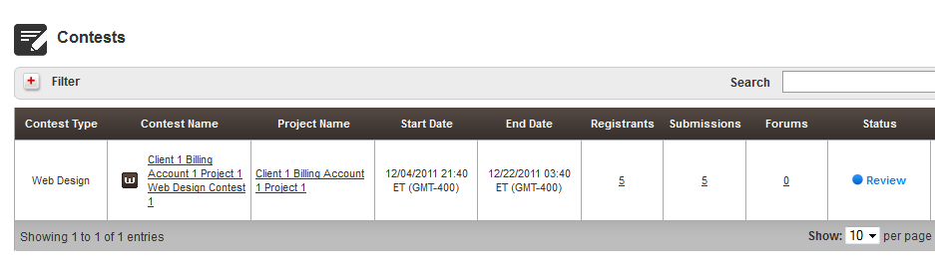

  - Verify Trigger Submission Viewer:

There is only one web design contest above, click it enter the contest details page. Click the Submissions Tab. It directs to the submissions page, you can click the submission thumb or hover and click the blue button to enter the new submission view.

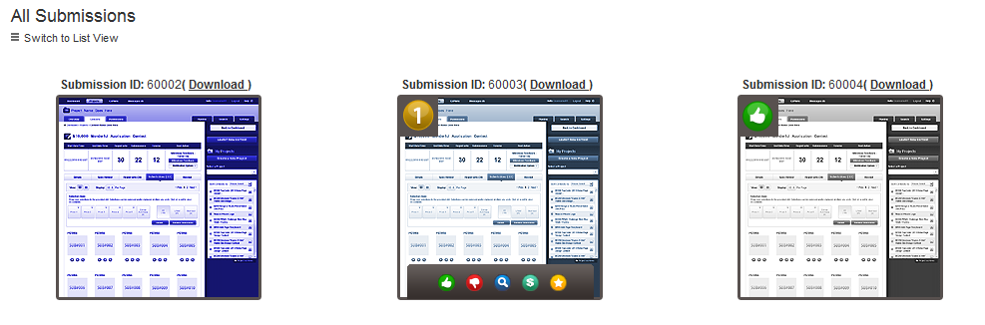

  - Verify Submission Viewer Grid View and Single View:

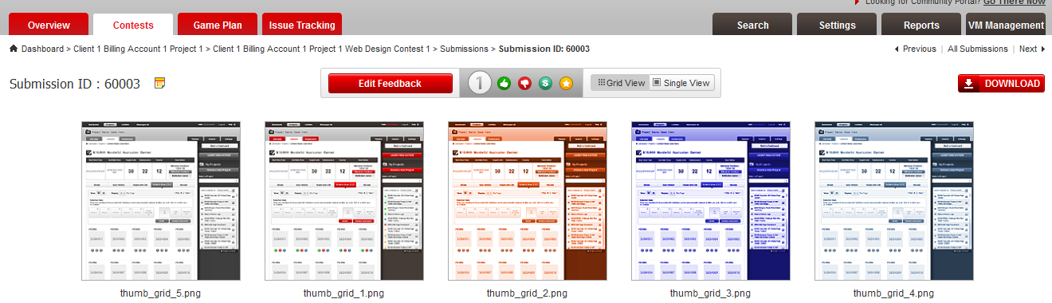
Checks the breadcrumbs, Previous | All Submissions | Next bar, Add/Edit Feedback, thumb up, thumb down, extra purchase, rank buttons etc to verify the functions are implemented. Below are some screens:
First submission, no Previous:



Thumb up:
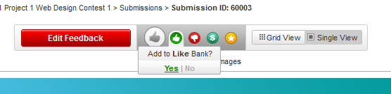

Set rank:

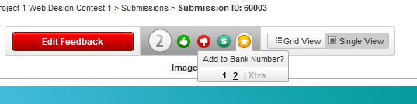

Submission Info:

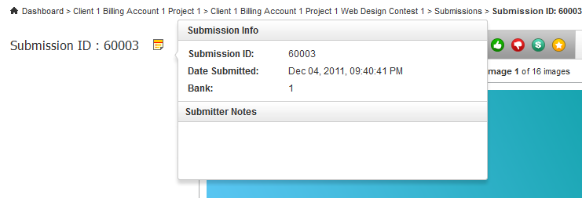

Edit Feedback (Edit if previous not empty, otherwise Add Feedback):
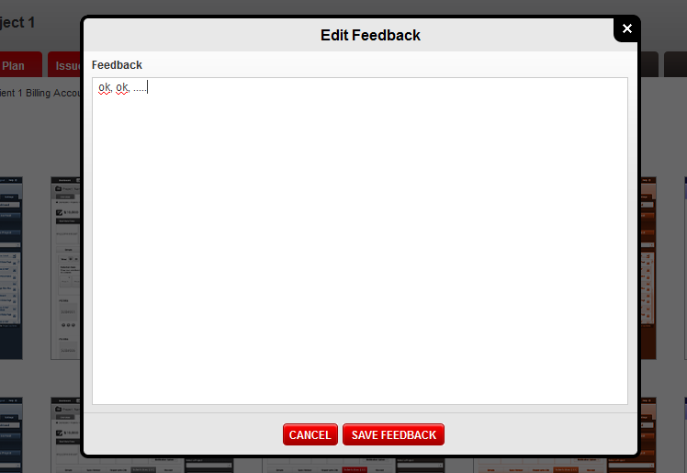

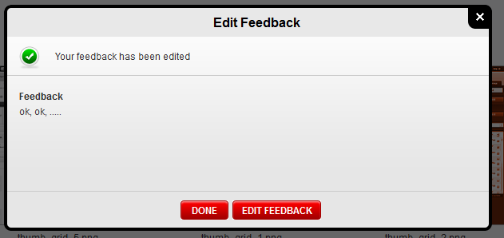

Click the Grid View/Single View switch to switch between grid view and single view.

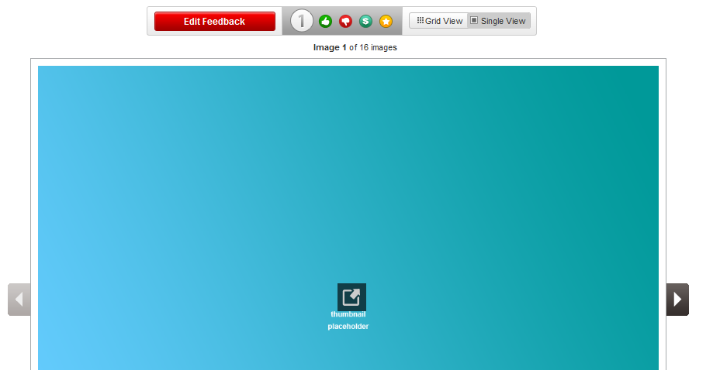

When use clicks the grid view or single view picture, the app will direct to the full size view.

  - Verify Submission Viewer Full Size View:
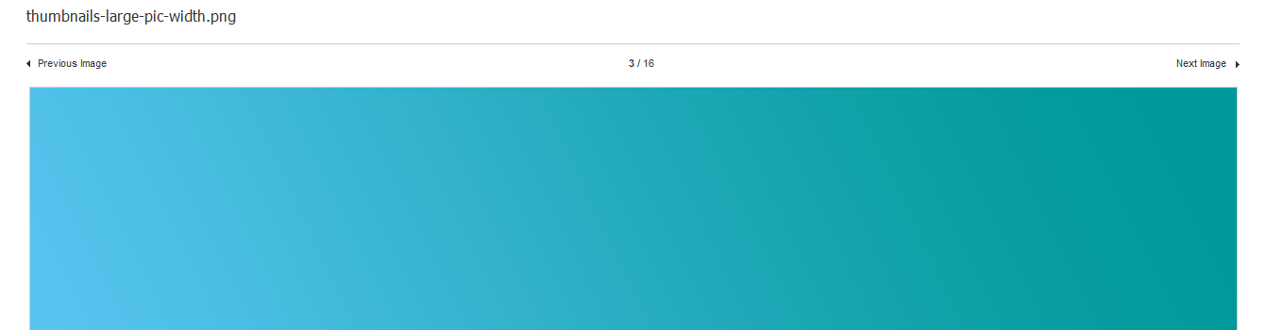
Check the file name, middle numbers. Click the left Previous Image and right Next Image to check if the image and all other info updated accordingly.

Resource Contact List

Name | Resource Email
TCSASSEMBLER

